Gaussian Naïve Bayes Classifiers Results

1. Synthetic Dataset 1 Results:

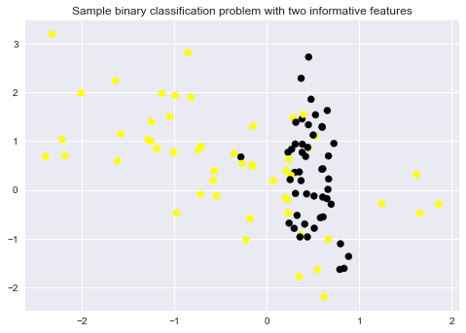

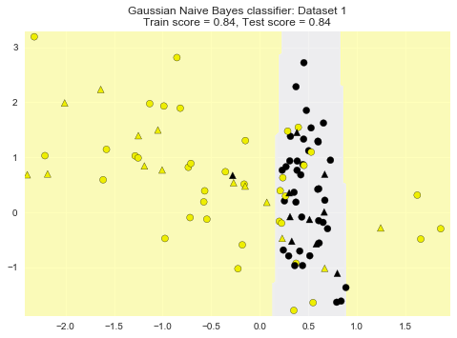

1. Synthetic Dataset 2 Results:

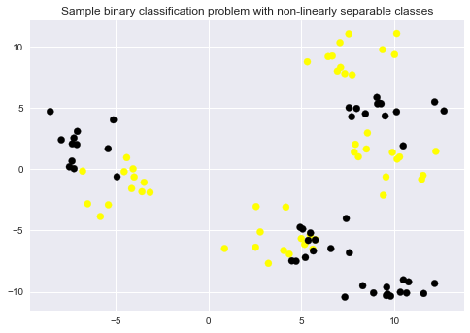

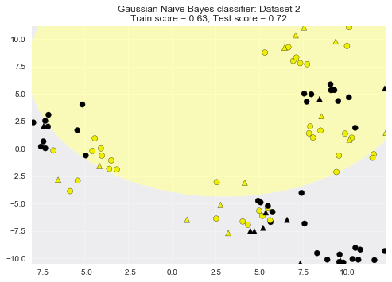

1. Breast cancer dataset Results

Accuracy of GaussianNB classifier on training set: 95.07 %

Accuracy of GaussianNB classifier on test set: 93.71 %